Intro scene

Kittens are kidnapped. kidnapper(alien) demands 50 gems ransom. Kids are told by signer to help Iris rescue them by collecting 25 gems.
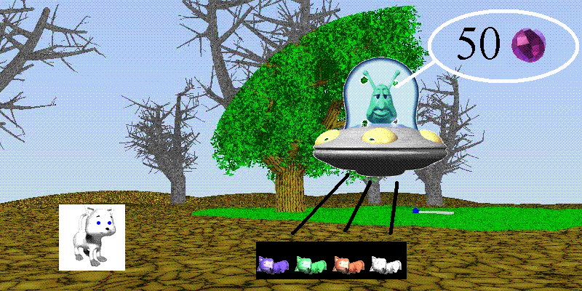
Kids then go to maze scene
Maze scene
Maze scene- gets kids from one scene to another allowing them to navigate through landscape to 4 different houses When they reach an entrance they go randomly into either a room of the appropriate word/list/chunk level or another maze scene. .This should provide freshness to the game. The maze scene is for fun and to make room scenes look unfamiliar

Use lady bug maze game as basis for code

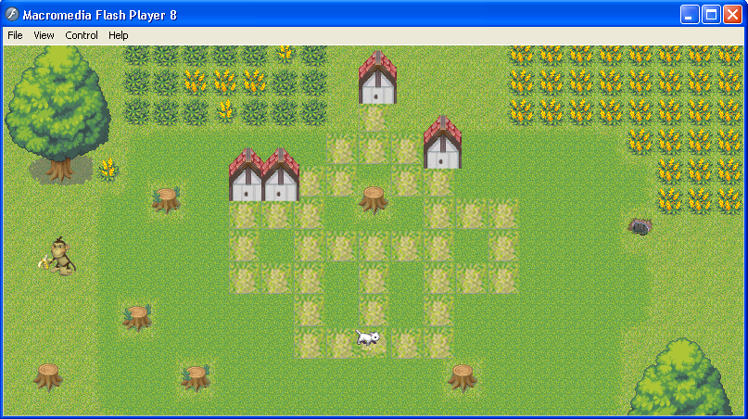

Room scene
When Iris enters room Kids can see who protects a gem (e.g., alligator on green wall) Kids tell Iris. If correct Iris goes and poofs villain(turns it to a monkey?) and gets gem. Gem flies over to score area and score increases by one.

The code from the original Castle Quest can be used as a base.

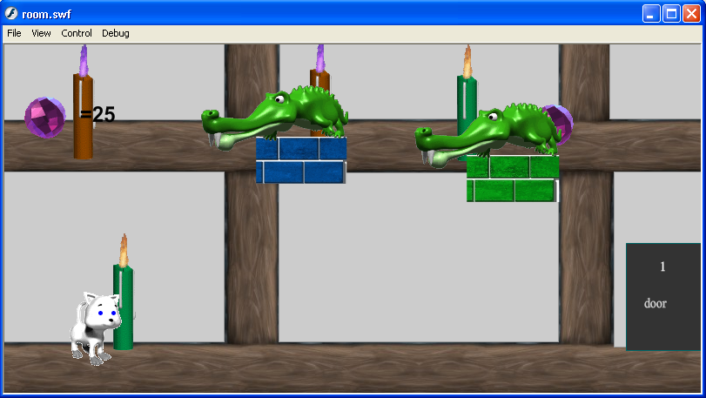

Occasionally when Iris enters a room she will be in a pirate scene. Iris and alien with numchuck will fight while other alien takes (maybe -5) gems which will be subtracted from total. When this is done the aliens fade out and Iris goes to door to go to next maze. (Make this animation)
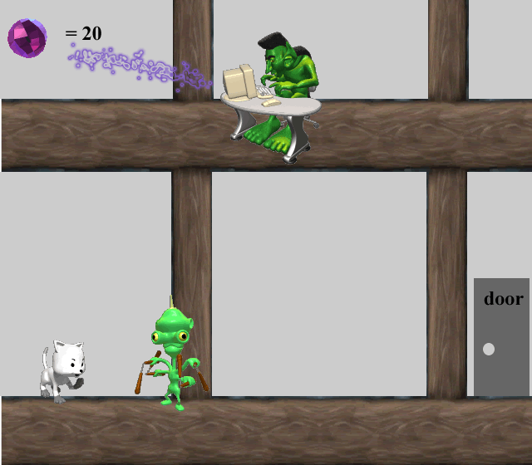

Bonus scene- There are 5 gems to be gotten to make up for the 5 the pirate stole.
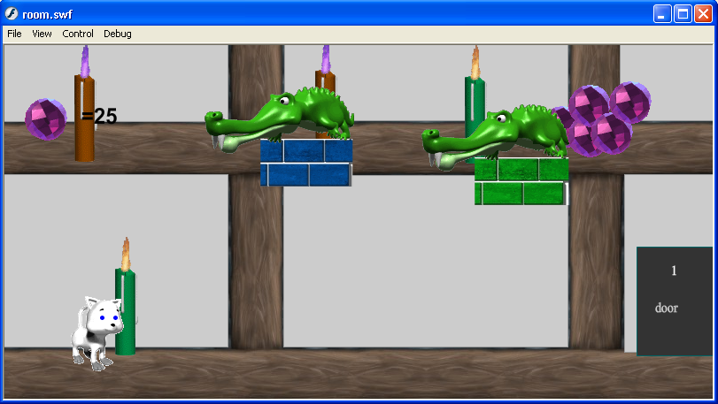
After Bonus room the Pirate room will appear or vice-versa so score is not affected. The rooms cancel each other out.
No gem room
Have a room where there are no villains or gems. It will simply be an animation in which Iris looks puzzled (? In thought bubble) and then walks to door and out to maze.

Game end
When kids have 50 gems they go to the kidnappers hideout to rescue the kittens and pull a “Puss in boots” trick so that the kittens go free and Iris keeps the gems and gives them. She can turn the bad aliens into monkeys. Then fade to closing scene of Iris and kittens with ILY.

